**MEDICAL EXPERT SYSTEM**

**PROBLEM STATEMENT:**

To develop software based **“MEDICAL EXPERT SYSTEM”** for supporting in diagnosis of disease using software rational rose with various UML diagrams.

**PROBLEM DESCRIPTION:**

The activities carried out in hospitals are done manually till now. If we want to get any patient detail it is very difficult to search all the records. Moreover it will take more time and occupies a lot of space. The details about individual patient’s disease, symptoms and treatment can be added to the system. The details about the Doctors like their name, id can also be added. All above details can be viewed, modified and deleted. This project is all about medical expert system. This project is to manage the doctors and patients in a renounced expert system. The patients can give their symptoms and system would give the disease and the remedies for the disease. The disease and the remedies are given by doctors. The actors involved in the system are **patient (Human being)** and **doctors (Admin)**. The use cases involved in the system are **giving patient’s details** and **their symptoms** and **viewing the treatment**.

**3) SRS:**

**a) INTROUCTION**

1. **PURPOSE**

The purpose of the document is to collect and analyze all assorted ideas that have come up to define the system, its requirements with respect to users. In short, the purpose of this SRS document is to provide a detailed overview of our software product, its parameters and goals. This document describes the project's target audience and its user interface, hardware and software requirements. It defines how our client, team and audience see the product and its functionality. Nonetheless, it helps any designer and developer to assist in software delivery lifecycle (SDLC) processes.

1. **SCOPE**

Primarily, the scope pertains to the medical expert system. It focuses on patients and helps them to get relieved from the disease by providing remedies. The system is used all hospitals. This system is used because it is user friendly. The system gives the treatment of respected disease. This system can be used with the minimum requirement specified. So this does not occupy more space.

1. **DEFINITION,ACRONYMS AND ABBREVIATIONS**

MES- Medical Expert System

SRS- Software Requirement Specification

GUI- Graphical User Interface

HTML-Hyper Text Markup Language

SQL-Structured Query Language

JDBC-Java Database Connectivity

1. **SYSTEM REQUIREMENT SPECIFICATION**

**HARDWARE**:

PROCESSOR: PENTIUM IV 2.6 GHZ

RAM: 512 MB DD RAM

MONITOR: 15’’ COLOR

HARD DISK: 250GB

CDDRIVE: LG52X

KEYBOARD: SATNDARD 102 KEYS

MOUSE: OPTICAL MOUSE

**SOFTWARE:**

FRONT END: HTML

BACK END: MY SQL

OPERATING SYSYEM: WINDOWS XP, WINDOWS 8, WINDOWS 10.

**b)GENERAL DESCRIPTION**

The proposed system that is being developed is user friendly system. The processing speed is very high when compared to the existing system. The space occupied by the proposed system in the memory is also very less. The doctor details can be known. There is review of details of disease treatment. This system offers to know the details and treatment of disease. The patient gives the symptoms to the system .The system analysis for treatment. The patient receives the prescription from system.

**c)SPECIFIC REQUIREMENTS**

1. **EXTERNAL INTERFACE REQUIREMENTS:**

* **USER INTERFACE REQUIREMENTS:**

The user interface (UI) is everything designed into an information device with which a human being may interact -- including display screen, keyboard, mouse, light pen, the appearance of a desktop, illuminated characters, help messages, and how an application program or a Web site invites interaction and responds to it. In early computers, there was very little user interface except for a few buttons at an operator's console. The user interface was largely in the form of punched card input and report output. The user interface can arguably include the total "user experience," which may include the aesthetic appearance of the device, response time, and the content that is presented to the user within the context of the user interface.

1. Login Module - The login module helps to get into the Medical expert system. The user name and password is obtained from the user and is verified and then goes on to the next screen.
2. Selection module -The selection module is used to select one of the available options. The available options are patient and doctor details. Each module is clicked the respective module opens.
3. Patients Detail module - In this module patient enter details about his/her symptoms and submit the record to receive remedy from system.
4. Doctor’s Login module - This Login module only for doctors to give remedies and disease name for patient’s details which they posted and recorded in database.
5. Treatment module – In this module patient can view his/her remedies from doctor through system**.**

* **HARDWARE INTERFACE REQUIREMENTS**

|  |  |
| --- | --- |
| Ram | 1GB |
| Hard Disk | 160GB |
| Processor | Pentium-4 |
| Operating System | Win XP/2000/98 |
| Mother Board | Intel d856 |
| Keyboard | Microsoft keyboard |
| Mouse | Microsoft optical |
|  |  |
| Monitor | LG 17”flatiron CRT |
|  |  |
|  |  |

* **SOFTWARE INTERFACE REQUIREMENTS**

OPERATING SYSTEM: WIN2000/XP

PROGRAMMING PACKAGE: HTML

DATABASE: MY SQL

DESIGING SOFTWARE: RATIONAL ROSE 4.2.0

### **COMMUNICATION INTERFACE**

The MES shall use the HTTP protocol for communication over the internet and for the intranet communication will be through TCP/IP protocol suite.

1. **FUNCTIONAL REQUIREMENTS:**

**USER LOGIN:**

The login module helps to get into the Medical expert system. The user name and password is obtained from the user and is verified and then goes on to the next screen.

**SELECTION MODULE:**

The selection module is used to select one of the available options. The available options are patient and doctor details. Each module is clicked the respective module opens.

**PATIENT DETAILS:**

In this Patient details module patient enter details about his/her symptoms and submit the record to receive remedy from system.

**TREATMENT:**

In this module patients can view his/her remedies from doctor through system.

**DOCTOR LOGIN:**

This Login module only for doctors to give remedies and disease name for patient’s details which they posted and recorded in database.

**USE CASES**

**Use Case1: User Login**

The login module helps to get into the Medical expert system. The user name and password is obtained from the user and is verified and then goes on to the next screen.

**ACTOR:**

Human being

**INPUT:**

The human beings enter user name and password.

**OUTPUT:**

The user can access the system and directed to selection module.

**Use Case2: Selection**

The selection module is used to select one of the available options. The available options are patient and doctor details. Each module is clicked the respective module opens.

**ACTOR:**

Human being

**INPUT:**

The user can select the respective module.

**OUTPUT:**

The users are directed to selected modules.

**Use Case3: Patient’s Details**

In this Patient details module patient enter details about his/her symptoms and submit the record to receive remedy from system.

**ACTOR:**

Human being

**INPUT:**

The patient gives their symptoms, name, age etc.

**OUTPUT:**

The data is stored in the database of the system to get remedies.

**Use Case4: Treatment**

In this module patients can view his/her remedies from doctor through system.

**ACTOR:**

Admin

**INPUT:**

The data is retrieved from the database.

**OUTPUT:**

The disease and remedy for the disease is given to user.

1. **NON FUNCTIONAL REQUIREMENTS:**

* **Security**

The system use SSL (secured socket layer) in all transactions that include any confidential patient information. The system must automatically log out all patients after a period of inactivity. The system should not leave any cookies on the patient’s computer containing the user’s password. The system’s back-end servers shall only be accessible to authenticated administrator. Sensitive data will be encrypted before being sent over insecure connections like the internet.

* **Reliability**

The system provides storage of all databases on redundant computers with automatic switchover. The reliability of the overall program depends on the reliability of the separate components. The main pillar of reliability of the system is the backup of the database which is continuously maintained and updated to reflect the most recent changes. Thus the overall stability of the system depends on the stability of container and its underlying operating system.

* **Availability**

The system should be available at all times, meaning the user can access it using a web browser, only restricted by the down time of the server on which the system runs. In case of a of a hardware failure or database corruption, a replacement page will be shown. Also in case of a hardware failure or database corruption, backups of the database should be retrieved from the server and saved by the administrator. Then the service will be restarted. It means 24 X 7 availability.

* **Maintainability**

A commercial database is used for maintaining the database and the application server takes care of the site. In case of a failure, a re-initialization of the program will be done. Also the software design is being done with modularity in mind so that maintainability can be done efficiently.

* **Portability**

The application is HTML and scripting language based. So the end-user part is fully portable and any system using any web browser should be able to use the features of the system, including any hardware platform that is available or will be available in the future. An end-user can use this system on any OS; either it is Windows or Linux. The system shall run on PC, Laptops, and PDA etc.

1. **DESIGN CONSTRAINTS**

The system shall be built using a standard web page development tool that conforms to Microsoft’s GUI standards like HTML, XML etc.

* **Hardware Limitations:**

There must be 64 MB on board memory

* **Control Functions:**

The software must be very user friendly and display appropriate error messages.

* **Interfaces to other applicants**:

Not applicable

* **Parallel operations**:

It must support many users simultaneously.

* **Reliability requirements:**

Data redundancy and use of special/blank characters must be avoided.

* **Safety/security considerations**:

The applicant must be exited always normally.

1. **LOGICAL DATABASE REQUIREMENTS**

Database is a place/container where all the data is stored. The database management system used in the system is MY SQL. MY SQL is an [open-source](https://en.wikipedia.org/wiki/Open-source) [relational database management system](https://en.wikipedia.org/wiki/Relational_database_management_system)(RDBMS).Its name is a combination of "My", the name of co-founder [Michael Widenius](https://en.wikipedia.org/wiki/Michael_Widenius)' daughter, and "[SQL](https://en.wikipedia.org/wiki/SQL)", the abbreviation for [Structured Query Language](https://en.wikipedia.org/wiki/Structured_Query_Language). In a database, we would be grouping only related data together and storing them under one group name called table. This helps in identifying which data is stored and under what name. It reduces the time to search for a particular data in a whole database. The MES must be able to use several data formats according to the data formats that are provided by the data bases of expert systems. A transaction should have all the properties of a data base transaction (Atomicity, Consistency, Isolation, Durability).In this system we have three tables to store the data. Patients table to store the symptoms that have been entered by the human being. Doctor’s table to store doctors details who act as an admin. The treatment table would give remedies for the disease.

1. **OTHER REQUIREMENTS**

NIL

**4) DESIGN AND IMPLEMENTATION:**

**UML:**

The **Unified Modeling Language** is a standard visual modeling language intended to be used for

* modeling business and similar processes,
* analysis, design, and implementation of software-based systems

UML is a common language for business analysts, software architects and developers used to describe, specify, design, and document existing or new business processes, structure and behavior of artifacts of software systems.

UML can be applied to diverse **application domains** (e.g., banking, finance, internet, aerospace, healthcare, etc.) It can be used with all major object and component **software development methods** and for various **implementation platforms** (e.g., J2EE, .NET).

UML is a standard modeling **language**, not a **software development process.**

* provides guidance as to the order of a team’s activities,
* specifies what artifacts should be developed,
* directs the tasks of individual developers and the team as a whole, and
* offers criteria for monitoring and measuring a project’s products and activities.

**TYPES OF UML DIAGRAMS:**

* Use-case diagrams
* Sequence diagrams
* Collaboration diagrams
* Activity diagrams
* Class diagrams
* State diagrams

**USE CASE DIAGRAM:**

**DEFINITON:**

A use case illustrates a unit of functionality provided by the system. The main purpose of the use-case diagram is to help development teams visualize the functional requirements of a system, including the relationship of "actors" to essential processes, as well as the relationships among different use cases. Use-case diagrams generally show groups of use cases -- either all use cases for the complete system, or a breakout of a particular group of use cases with related functionality. A use-case diagram is typically used to communicate the high-level functions of the system and the system's scope.

**DESCRIPTION:**

Actor

Use case

Include

Generalization

Extends

**EXPLANATION:**

In this case the patient informs to the system about symptoms. The use cases used here are symptoms disease medication and insufficient information. The treatment can be searched by database stored in medical expert system.

**USE CASE DIAGRAM FOR MEDICAL EXPERT SYSTEM**



**SEQUENCE DIAGRAM**

**DEFINITION:**

Sequence diagrams show a detailed flow for a specific use case. They show the calls between the different objects in their sequence. A sequence diagram has two dimensions: the **vertical dimension** shows the sequence of messages/calls in the time order that they occur, the **horizontal dimension** shows the object instances to which the messages are sent. A sequence diagram is very simple to draw. Across the top of your diagram, identify the class instances. If a class instance sends a message to another class instance, draw a line with an open arrowhead pointing to the receiving class instance; place the name of the message/method above the line. Optionally, for important messages, you can draw a dotted line with an arrowhead pointing back to the originating class instance label the return value above the dotted line.

**DESCRIPTION**

Actor

Class instance

Connection lines

Messages

**EXPLANATION**

The first step is to give symptoms. Then the system identifies the disease .After identifying it gives details of the respected medicine and dosage to the patient if it unidentified the disease it displays insufficient information..

**SEQUENCE DIAGRAM FOR MEDICAL EXPERT SYSTEM**



**COLLOBORATION DIAGRAM**

**DEFINITION:**

Collaboration diagrams provide a view of the interactions or structural relationships between objects in the current model. The collaboration diagram emphasizes the relationship between objects whereas sequence diagrams emphasize the sequence of events. Collaboration diagrams contain objects, links, and messages. Use collaboration diagrams as the primary vehicle to describe interactions that express decisions about system behavior.

**DESCRIPTION**

Actor

Class instance

Connection lines

Messages

**EXPLANATION**

The actor here is the client. Then the source client is dials the number and waits for availability. The operator gives a connection between them. Once the connection get, the clients starts their communication and ends call after finish.

**COLLOBORATION DIAGRAM FOR MEDICAL EXPERT SYSTEM**



**ACTIVITY DIAGRAM**

**DEFINITION**

Activity diagrams show the procedural flow of control between two or more class objects while processing an activity. Activity diagrams can be used to model higher-level business process at the business unit level, or to model low-level internal class actions. Activity diagrams are best used to model higher-level processes. This is because activity diagrams are "less technical" in appearance, compared to sequence diagrams. The activity is modeled by drawing a rectangle with rounded edges, enclosing the activity's name. Activities can be connected to other activities through transition lines, or to decision points that connect to different activities guarded by conditions of the decision point. Activities that terminate the modeled process are connected to a termination point. Optionally, the activities can be grouped into swim lanes.  THERE CAN BE ONLY ONE START AND ONE STOP.

**DESCRIPTION**

Start

Stop

Swim lanes

Rectangular rounded edged box

Decision box-diamond

Merge

Fork

Join

Connection lines

**EXPLANATION**

The first step is to give symptoms. Then the system identifies the disease. After identifying it gives details of the respected medicine and dosage to the patient if it unidentified the disease it displays insufficient information.

**ACTIVITY DIAGRAM FOR MEDICAL EXPERT SYSTEM**

 **CLASS DIAGRAM**

**DEFINITION:**

The class diagram shows how the different entities relate to each other. It shows the static structures of the system. A class diagram can be used to display logical classes, which are typically the kinds of THINGS, the business people in an organization talk about. Class diagrams can also be used to show implementation classes, which are the things that programmers typically deal with. An implementation class diagram will probably show some of the same classes as the logical class diagram. The implementation class diagram won't be drawn with the same attributes, however, because it will most likely have references to things like Vectors and Hash Maps.

**DESCRIPTION:**

Rectangular box with three horizontal sections

Generalization

Association

Aggregation

Navigation

Multiplicity

**EXPLANATION:**

The detail of both management (reception) and the user (patient and staff) all combine together to give the details. Generalization is show here. Multiplicity is show between patient and system.

**CLASS DIAGRAM FOR MEDICAL EXPERT SYSTEM**



**STATE DIAGRAM:**

State diagram describes different states of a component in a system. The states are specific to a component/object of a system. A State chart diagram describes a state machine.

**PURPOSE :**

State chart diagram is one of the five UML diagrams used to model dynamic nature of a system. They define different states of an object during its lifetime. And these states are changed by events. State chart diagrams are useful to model reactive systems. Reactive systems can be defined as a system that responds to external or internal events.

State chart diagram describes the flow of control from one state to another state. States are defined as a condition in which an object exists and it changes when some event is triggered. So the most important purpose of State chart diagram is to model life time of an object from creation to termination.

State chart diagrams are also used for forward and reverse engineering of a system. But the main purpose is to model reactive system.

Following are the main purposes of using State chart diagrams:

* To model dynamic aspect of a system.
* To model life time of a reactive system.
* To describe different states of an object during its life time.
* Define a state machine to model states of an object.

**STATE DIAGRAM FOR MEDICAL EXPERT SYSTEM**



**5 ) CODING:**

**FRONT END (HTML&CSS)**

**1.LOGIN SCREEN**

<link rel="stylesheet" type="text/css" href="login1.css">

<form action="action_page.php">

<div class="imgcontainer">

<img src="login.png" alt="Images" class="images">

</div>

<div class="container">

<label><b>Username</b></label>

<input type="text" placeholder="Enter Username" name="uname" required>

<label><b>Password</b></label>

<input type="password" placeholder="Enter Password" name="psw" required>

<button type="submit"><a href="expert.html">LOGIN</a></button>;

<input type="checkbox" checked="checked"> Remember me

</div>

<div class="container" style="background-color:#f1f1f1">

<button type="button" class="cancelbtn">Cancel</button>

<span class="psw">Forgot <a href="#">password?</a></span>

</div>

</form>

form {

border: 3px solid #f1f1f1;

}

/* Full-width inputs */

input[type=text], input[type=password] {

width: 100%;

padding: 12px 20px;

margin: 8px 0;

display: inline-block;

border: 1px solid #ccc;

box-sizing: border-box;

}

/* Set a style for all buttons */

button {

background-color: #4CAF50;

color: white;

padding: 14px 20px;

margin: 8px 0;

border: none;

cursor: pointer;

width: 100%;

}

/* Extra style for the cancel button (red) */

.cancelbtn {

width: auto;

padding: 10px 18px;

background-color: #f44336;

}

/* Center the avatar image inside this container */

.imgcontainer {

text-align: center;

margin: 24px 0 12px 0;

}

/* Avatar image */

img.avatar {

width: 40%;

border-radius: 50%;

}

/* Add padding to containers */

.container {

padding: 16px;

}

**2. SELECTION MODULE**

<!DOCTYPE html>

<html>

<style>

form {

border: 3px solid #f1f1f1;

margin: 0 auto;

width: 400px;

}

h2{

text-align: center;}

body {

background-image:hosp.jpg;

background-size: cover;

background-attachment: fixed;

}

button {

background-color: #4CAF50;

color: white;

padding: 14px 20px;

margin: 8px 0;

border: none;

cursor: pointer;

width: 100%;

}

.cancelbtn {

width: 100%;

padding: 14px 20px;

background-color: #f44336;

}

/* Change styles for span and cancel button on extra small screens */

</style>

<body>

<h2>MEDICAL EXPERT SYSTEM </h2>

<form action="action_page.php">

<body background="hosp.jpg">

<div class="container">

<button type="submit"><a href="patient.html">PATIENT DETAILS</a></button>;

<button type="submit"><a href="doctor.html">DOCTOR DETAILS</a></button>;

<button type="button" class="cancelbtn">EXIT</button>

</div></form></body></html>

**3.PATIENT DETAILS:**

<!DOCTYPE html>

<html>

<style>

form {

border: 20px solid #f1f1f1;

margin: 0 auto;

width: 400px;

}

h2{

text-align: center;

}

body {

background-image:patient.jpg;

background-size: cover;

background-attachment: fixed;

}

input[type=text], input[type=age] ,input[type=sex],input[type=symptoms]{

width: 100%;

padding: 10px 10px;

display: inline-block;

border: 10px solid #ccc;

box-sizing: border-box;

}

button {

background-color: #4CAF50;

color: white;

padding: 14px 20px;

margin: 8px 0;

border: none;

cursor: pointer;

width: 100%;

}

.cancelbtn {

width: auto;

padding: 10px 18px;

background-color: #f44336;}

.cancellbtn {

width: auto;

padding: 10px 18px;

background-color: #0000FF;}

</style>

<body background="patient.jpg">

<h2>PATIENT DETAILS</h2>

</div>

<form action="treatments.jsp">

<div class="container">

<label><b>PATIENT NAME</b></label>

<input type="text" placeholder="Enter name" name="pName" required>

<label><b>AGE</b></label>

<input type="text" placeholder="Enter age" name="age" required> <label><b>GENDER</b></label>

<input type="text" placeholder="Enter gender" name="gender" required>

<label><b>SYMPTOMS</b></label>

<input type="text" placeholder="Enter symptom" name="symptoms" required>

<div class="container" style="background-color:#f1f1f1">

<input type="SUBMIT" class="cancelbtn" />

</div>

</form>

</body>

</html>

**4.DOCTOR DETAILS**

<!DOCTYPE html>

<html>

<style>

form {

border: 20px solid #f1f1f1;

margin: 0 auto;

width: 400px;

}

h2{

text-align: center;

}

body {

background-image:doc.jpg;

background-size: cover;

background-attachment: fixed;

}

input[type=text], input[type=password]{

width: 100%;

padding: 10px 10px;

display: inline-block;

border: 10px solid #ccc;

box-sizing: border-box;

}

button {

background-color: #4CAF50;

color: white;

padding: 14px 20px;

margin: 8px 0;

border: none;

cursor: pointer;

width: 100%;

}

.cancelbtn {

width: auto;

padding: 10px 18px;

background-color: #f44336;}

.cancellbtn {

width: auto;

padding: 10px 18px;

background-color: #0000FF;}

.cancelllbtn {

width: auto;

padding: 10px 18px;

background-color:#00FF00 ;}

</style>

<body>

<h2>DOCTOR LOGIN</h2>

<form action="doctors.jsp">

<body background="doc.jpg">

</div>

<div class="container">

<label><b>DOCTOR ID</b></label>

<input type="text" placeholder="Enter id" name="uname" required>

<label><b>PASSWORD</b></label>

<input type="password" placeholder="Enter password" name="pswd" required>

<div class="container" style="background-color:#f1f1f1">

<input type="SUBMIT" class="cancellbtn" />

<button type="button" class="cancelbtn">CANCEL</button>

</div></form></body></html>

**DATABASE:**

**TABLES:**

PATIENT DETAILS:

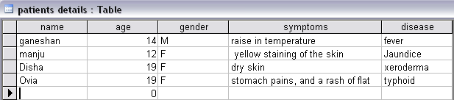

DOCTORS DETAILS:

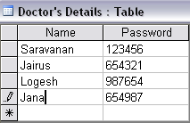

ABOUT DISEASE:

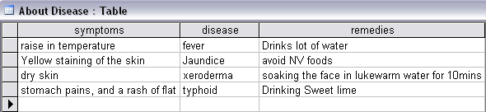

**JDBC:(jsp)**

**PATIENT MODULE**

<%@ page import ="java.sql.*" %>

<%@ page import ="javax.sql.*" %>

<%@page contentType="text/html" pageEncoding="UTF-8"%>

<!DOCTYPE html>

<%

String a=request.getParameter("pName");

String b=request.getParameter("age");

String c=request.getParameter("gender");

String d=request.getParameter("symptoms");

try{

Class.forName("com.mysql.jdbc.Driver");

Connection con = DriverManager.getConnection("jdbc:mysql://localhost:3306/medical", "root", "guruji");

Statement st=con.createStatement();

int i=st.executeUpdate("insert into patients_details(pname,age,gender,symptoms)values ('"+a+"','"+b+"','"+c+"','"+d+"')");

}

catch(Exception e){

System.out.print(e);

}

%>

**DOCTOR MODULE**

<%@ page import ="java.sql.*" %>

<%@ page import ="javax.sql.*" %>

<%@page contentType="text/html" pageEncoding="UTF-8"%>

<!DOCTYPE html>

<%

String a=request.getParameter("uname");

String b=request.getParameter("pswd");

try{

Class.forName("com.mysql.jdbc.Driver");

Connection con = DriverManager.getConnection("jdbc:mysql://localhost:3306/medical", "root", "guruji");

Statement st=con.createStatement();

int i=st.executeUpdate("insert into doctors_details(name,password)values ('"+a+"','"+b+"')");

}

catch(Exception e){

System.out.print(e);

}

response.sendRedirect("expert.html");

//link to html

%>

**TREATMENT MODULE**

<%@ page import="java.sql.*" %>

<%@ page language="java" import="java.sql.*"%>

<HTML>

<style>

h2{

text-align: center;

}

body {

background-image:treat.jpg;

background-size: cover;

background-attachment: fixed;

}

table, th, td {

border: 4px solid black;

}

th {

background-color: #4CAF50;

color: white;

}

</style>

<body background="treat.jpg">

<h2>TREATMENT</h2>

<%

String d=request.getParameter("symptoms");

Class.forName("com.mysql.jdbc.Driver");

Connection connection = DriverManager.getConnection("jdbc:mysql://localhost:3306/medical", "root", "guruji");

Statement statement = connection.createStatement() ;

ResultSet resultset =

statement.executeQuery("select * from disease where symptoms = '" + d + "' " ) ;

%>

<TABLE BORDER="1">

<table align="center">

<TR>

<TH>symptoms</TH>

<TH>disease</TH>

<TH>remedies</TH>

</Tr>

<% while(resultset.next()){ %>

<TR>

<TD> <%= resultset.getString(1) %></td>

<TD> <%= resultset.getString(2) %></TD>

<TD> <%= resultset.getString(3) %></TD>

</Tr>

<% } %>

</TABLE>

</BODY>

</HTML>

**6.OUTPUT**

**LOGIN MODULE:**

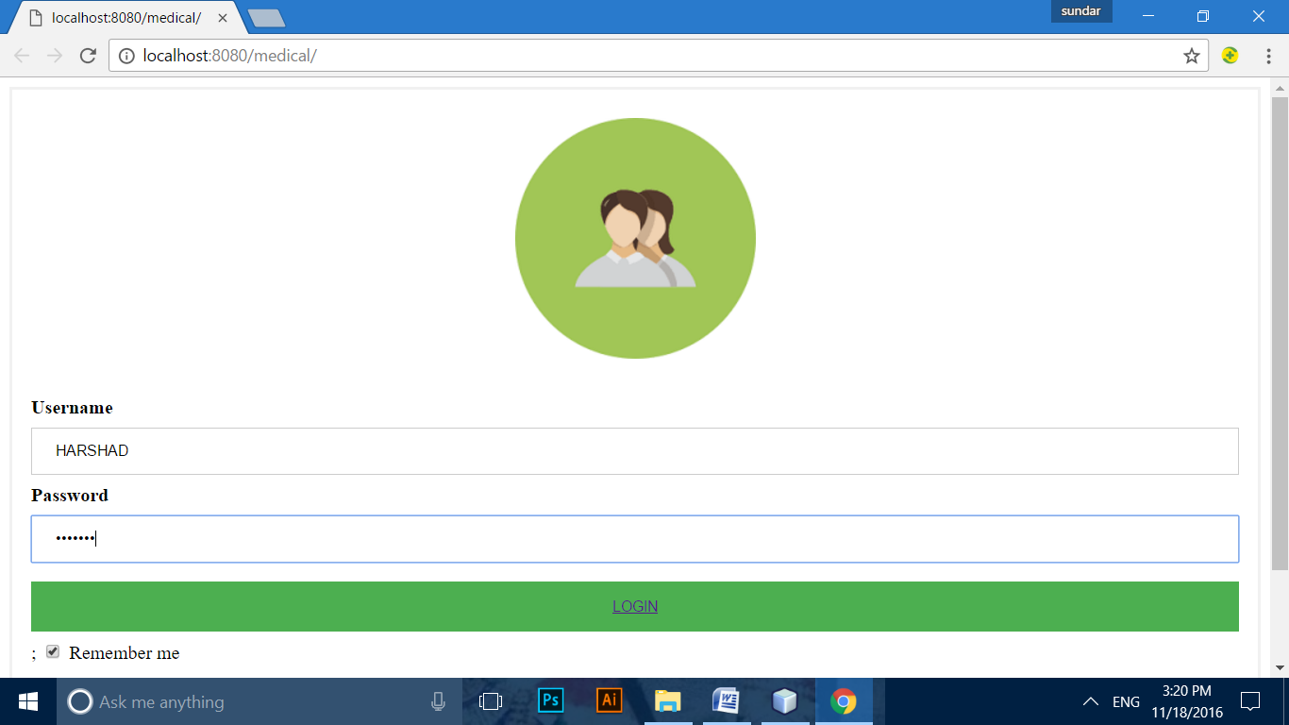

**SELECTION MODULE**:

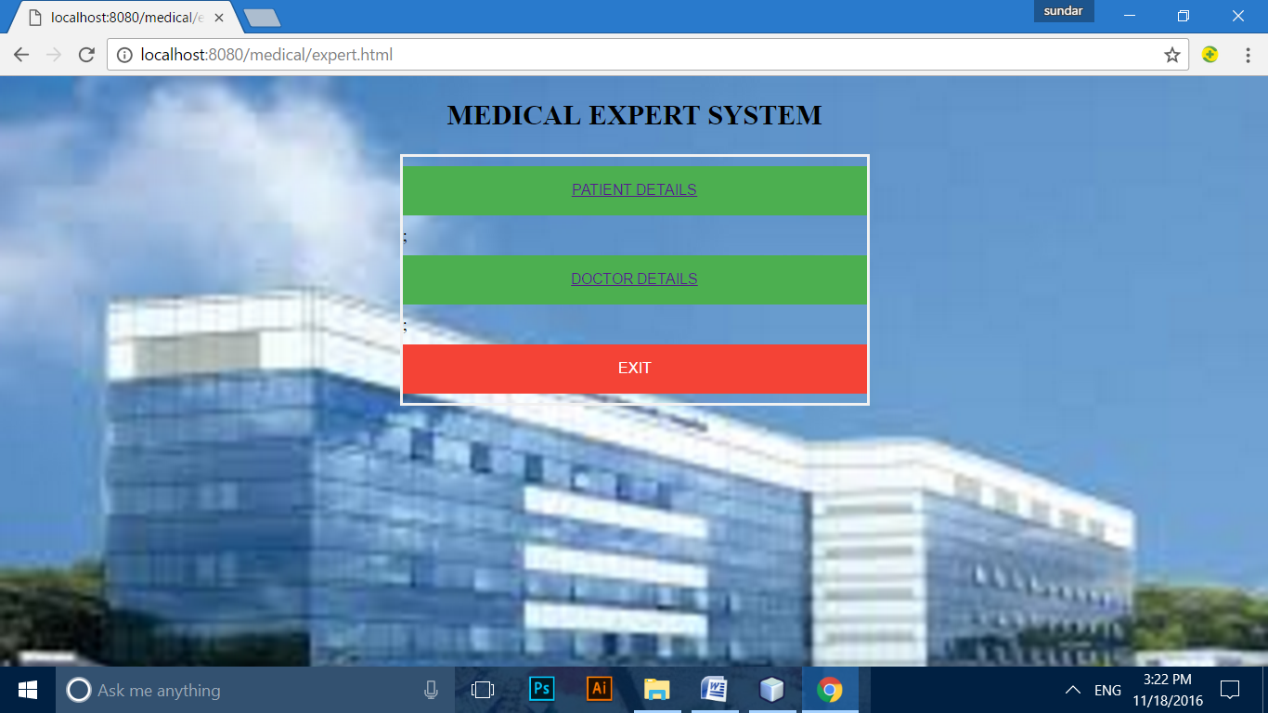

**DOCTOR DETAILS MODULE**:

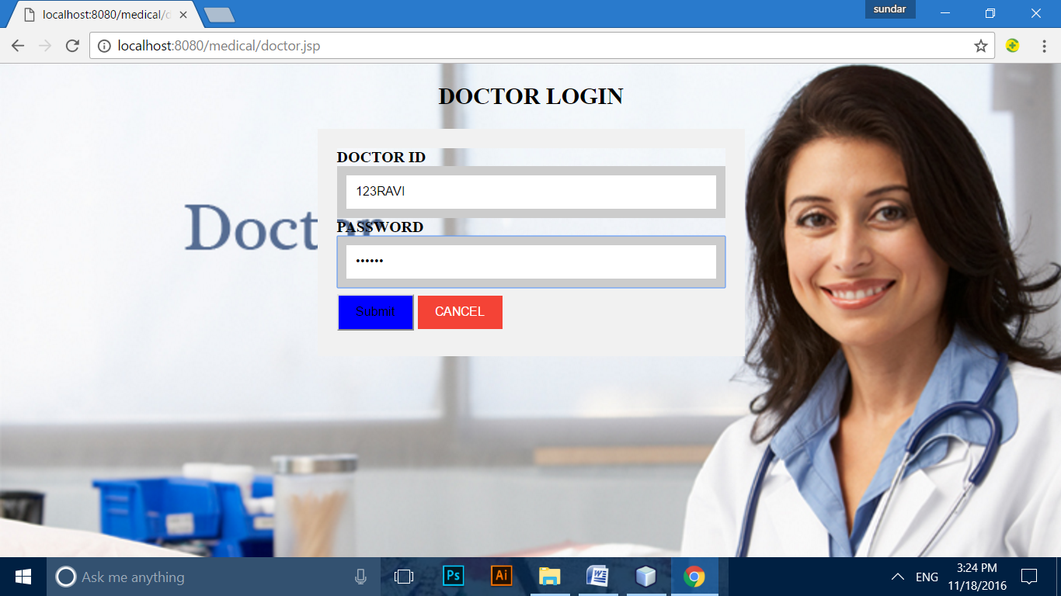

**PATIENT DETAILS MODULE:**

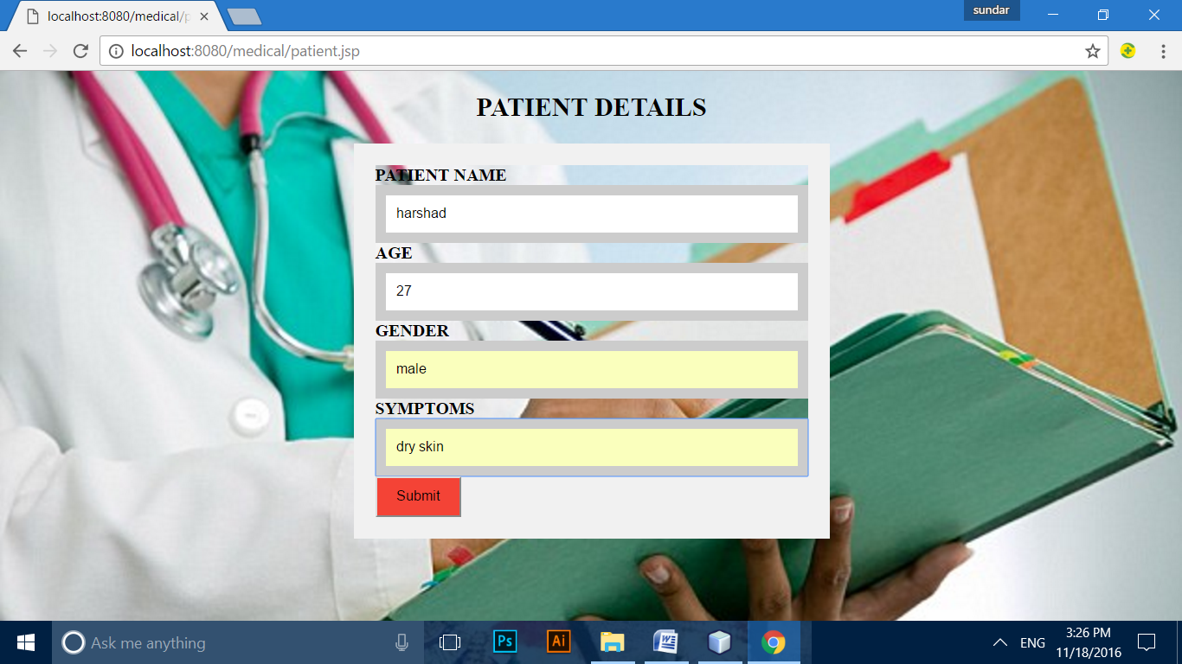

**SYMPTOMS MODULE**:

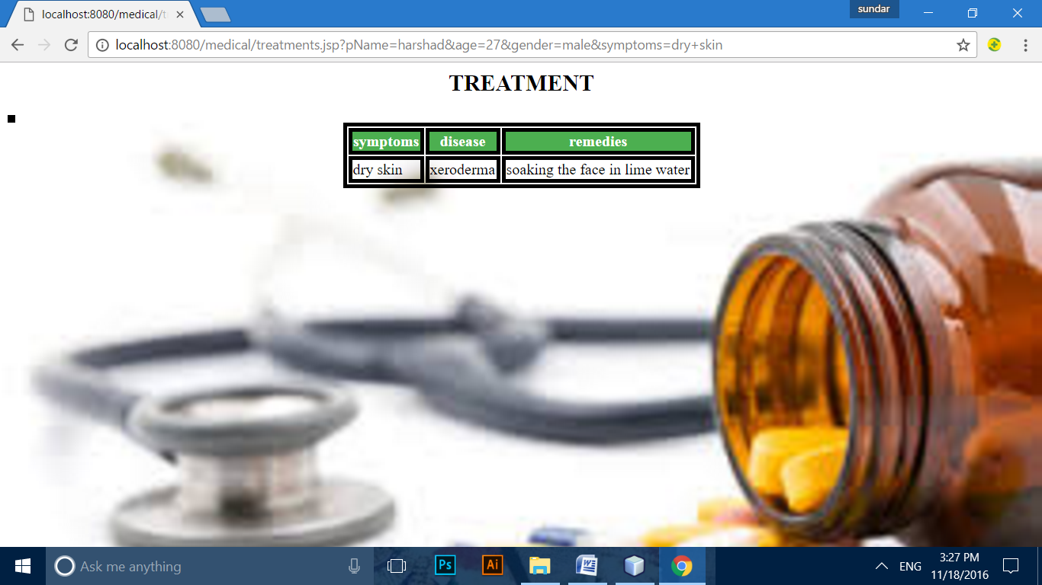

**7.CONCLUSION:**

The medical expert system is developed using software rational rose using UML diagrams.